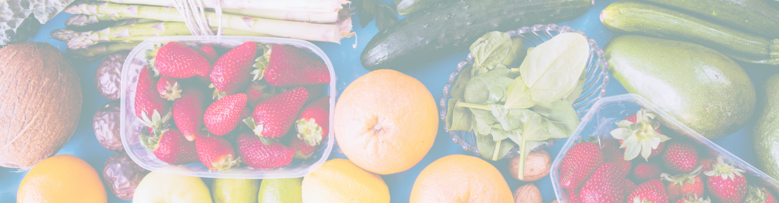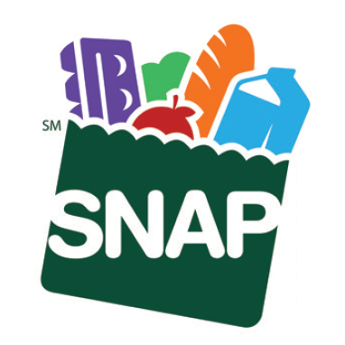We accept

Insert Farm Logo Here

Insert Farm Address Here

Insert Farm Phone Here

List farm products here: Include only Fruits and vegetables;

Meat, poultry, and fish;

Dairy products;

Breads and cereals;

Other foods such as snack foods and non-alcoholic beverages; and

Seeds and plants, which produce food for the household to eat.